Greater New York Technologist

Section Chapter of SNMMI
77 Glenbrook Rd. Unit 404
Stamford, CT. 06902
Ph: (609) 513-0380
W: https://gnycsnmmits.org/
E: greaternysnmts@hotmail.com
.

2003 Annual Meeting
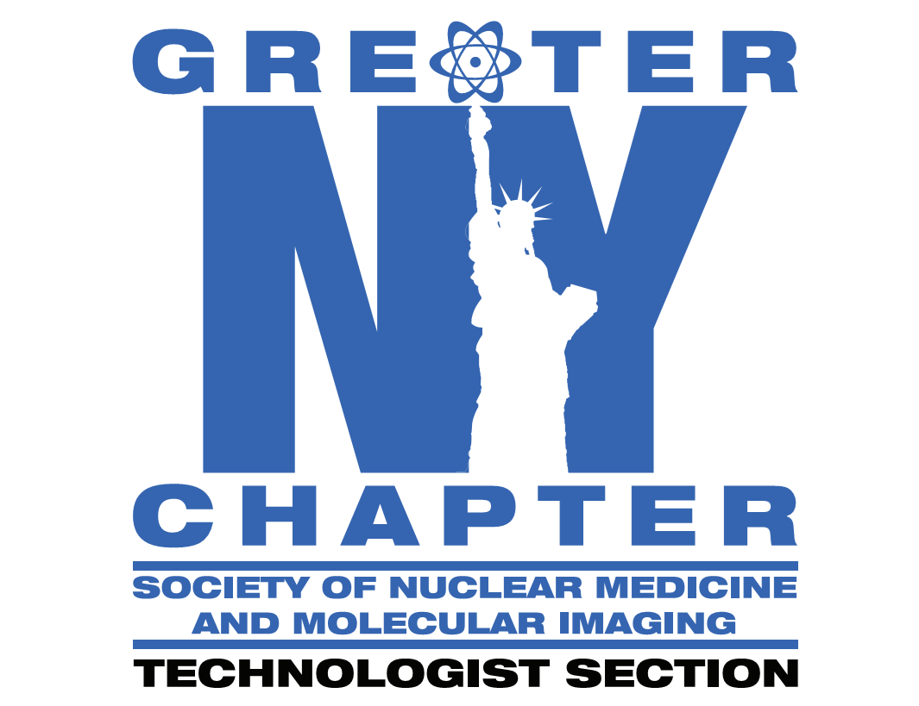

2025 Greater NY Technologist Section Chapter of SNMMI Spring Symposium
April 4-5, 2025
Hard Rock Hotel & Casino, Atlantic City, NJ

Educational Grantor, Sponsor & Exhibitor Prospectus

The 2025 Spring Symposium of the Greater NY Technologist Section Chapter of the Society of Nuclear Medicine and Molecular Imaging (GNYSNMMI) will be held April 4-5, 2025 at the Hard Rock Hotel & Casino in Atlantic City, NJ.

Join us as nationally recognized leaders discuss important topics in Nuclear Medicine and Molecular Imaging. The meeting will also include a limited number of tabletop exhibits of Nuclear Medicine equipment, supplies and services. There will be ample time for networking between technologists and suppliers.

Attendance
Projected attendance is 120-150 nuclear medicine technologists and students from the leading hospitals and healthcare facilities in the Northeast.

Vendor Participation
Vendors may show their support for the Nuclear Medicine community and the GNYSNMMI Spring Symposium by providing an educational grant to support the educational program offered, or as a sponsor or an exhibitor. A block of rooms are reserved at the Hard Rock Hotel with rates of $79 for Thurs night and $249 for Fri/Sat nights for single and double, plus various fees and taxes required by state and hotel. To reserve a room online, go to https://book.passkey.com/go/GSON25Z. Please reserve your room before 11:59 pm EST on Thursday, March 20, 2025.

Exhibits: The tabletop exhibit spaces are available on a first come, first served basis. The Exhibit Area will be located convenient to the educational sessions and the networking functions. The continental breakfasts and coffee breaks will be held in the exhibit area. Cost per table is $1,200 for commercial companies and $500 for not-for-profit organizations. The price includes a 6’’skirted table, 2 chairs and up to (8) exhibitor badges. The floor is carpeted. An exhibit application is included as part of this prospectus. Exhibitors will need to pay for electrical and any other services required to run their exhibit space.

Educational Grants: The GNYSNMMI is seeking educational grants to support the educational aspect of the meeting.

Sponsorships: Sponsorship opportunities exist for the non-educational components of the meeting, including meal functions and social events. For specific information on the costs and benefits of the sponsorship opportunities, please review the 2025 GNYSNMMI Spring Symposium Grant/Sponsorship page included with this prospectus. For CME application purposes and to assure we can include your company name in the meeting syllabus and appropriate signage, please submit your application by Friday, March 7, 2025.

Meeting Schedule (subject to change)
Exhibit Set-up Thursday, April 3, 2025 4:00 pm – 7:00 pm (subject to change)
Friday, April 4, 2025 6:00 am – 7:00 am
Exhibit Hours Friday, April 4, 2025 7:00 am – 4:00 pm
Saturday. April 5, 2025 7:00 am – 10:30 am
Dismantle Saturday, April 5, 2025 10:30 am – 12:00 pm

Application
Applications for grants/sponsorships and exhibiting are attached as part of this prospectus. To register, please complete and return the applications to the address above, along with payment of the total due. The GNYSNMMI is a Not-for-Profit Association, Federal ID#: 16-1432806.

If paying by credit card, please contact our Treasurer, Gabriel Duah, at gkduah@gmail.com.

Questions?
For additional information concerning the meeting, contact GNYSNMMI Headquarters at the address above, or visit the GNYSNMMI website at https://gnycsnmmits.org/.

Additional Information:

- Information on shipping to the Hard Rock Hotel, ordering audio visual and submitting your names for badges will be sent in the coming weeks. Please pay attention to deadline dates.
- VOICE Credits for Vendors - Free registration will be provided to vendors who wish to participate and receive VOICE credit for attended sessions. You must wear your Vendor ID badge and be present for at least 90% of the lecture.

